**CS165 Project 2 Part 1 Report (Truncated)**

Professor Zhiyun Qian   
University of California, Riverside

By Sanchit Goel and Jiacheng Hou.

**Overview**

Figure 2 Authentication Function Overview

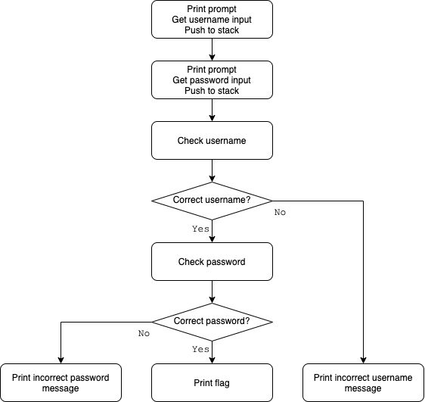

Running the toy program with random username and password we got  
(see figure 1):

Figure 1 Original Printout

Here is an overview of the logic of the   
authentication function at sub_401080 (see figure 2):

**Bypassing Username Check**

Here is a closer look on how the function checks if the user enters the correct username (see figure 3):

We can see, the function compares the inputted username against the correct username Using a loop. Each loop, it checks if the bytes are the same and if the byte in the inputted username is zero (indication it has reached the end.)

To bypass the username check, instead of comparing the byte from the inputted username in DL to the byte from the correct username at addr[ECX], we changed it to comparing to itself, which always yields true.

Figure 3 Check Username Algorithm

|  |  |
| --- | --- |
| Original | Patched |
|  |  |

Similarly, we changed the comparison on the next byte of the username to always be true (see figure 4 for table).

By making these changes, we successfully bypassed the program's username check and the program now always accepts the inputted username.

Figure 4 Patched Code to Bypass Username Check

After entering a random string as username, we got (see figure 5):

Figure 5   
Printout After Bypassing Username Check

**Bypassing Password Check**

We found the mechanism for checking password is the same as for checking username, with only some differences:

1. Load the correct password address and inputted password into EAX and ECX respectively.
2. If the bytes are different, then print incorrect password message.
3. If the end of the inputted password is reached and all its bytes are the same as those of the correct one, the flag string is printed.

|  |  |
| --- | --- |
| Before | After |
|  |  |

So, we made the similar changes to the comparisons so they would always be true (see figure 6 for table).

Figure 6  
Patched Code to Bypass Password Check

**Conclusion**

Since both username and password checks are bypassed, the toy program's entire authentication is bypassed. The program now gives out the flag string no matter what username or password we give.

Running the patched program with random strings as username and password, we got (see figure 7):

Figure 7   
Printout After Bypassing All Authentication Checks

And we got the flag: 34gdfh340234